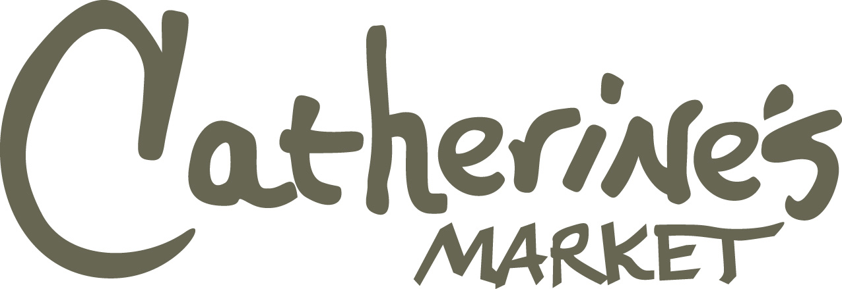
♦ Phone 256-215-7070♦ Fax 256-215-7071 ♦ ebrown@russelllands.com

Pick Up Date: _______________________ Time: ______________________

Name_____________________________________ Phone_________________________
Credit Card AMX – MC – VISA # ______________________________________________________________ Exp________________

IT ALL STARTS WITH THE BIRD…………..All turkeys include quart of stock and reheating instructions.

Joyce Farms All Natural Free-Range Turkeys
- Whole Turkey $5.09/lb. _____10-14 lb. _____16-20 lb. _____20-24 lb.
- Cooked Whole Turkey $7.99/lb. _____10-14 lb. _____16-20 lb. _____20-24 lb.
- Bone-In Turkey Breast $8.49/lb. _____10-12 lb.
- Cooked Bone-In Turkey Breast $10.99/lb. _____10-12 lb.
HOUSE MADE TRIMMINGS FOR YOUR TURKEY ……..
2 lbs. = 4-6 Servings
- Mac & Cheese $8.99/lb. _____ 2 lb. _____ 4 lb. ______ 6 lb.
- Broccoli Au Gratin $8.99/lb. _____ 2 lb. _____ 4 lb. ______ 6 lb.
- Sweet Potato Casserole $8.99/lb. _____ 2 lb. _____ 4 lb. ______ 6 lb.
- Squash Casserole $8.99/lb. _____ 2 lb. _____ 4 lb. ______ 6 lb.
- Green Bean Casserole $9.99/lb. _____ 2 lb. _____ 4 lb. ______ 6 lb.
- Twice Baked Mashed Potatoes $9.99/lb. _____ 2 lb. _____ 4 lb. ______ 6 lb.
- Cornbread Dressing w/Chicken $9.99/lb. _____ 2 lb. _____ 4 lb. ______ 6 lb.
- Corn Casserole $8.99/lb. _____ 2 lb. _____ 4 lb. ______ 6 lb.
_____ Giblet Gravy (quart).………. $9.99 _____ Cranberry Sauce (16 oz.).......……$7.99
_____ Chicken Stock (quart)………...$6.99 _____ Dinner Rolls (1 dozen)………..…$6.49

HOUSE BAKED SWEETS & TREATS FOR YOUR MEAL……
_____ Boulle 10” Round Sourdough “House Bread” $7.99 each
_____ Sour Cream Pound Cake $8.99 each
_____ Banana Pudding $10.99 each
_____ Pumpkin Bread $9.99 each
_____ Banana Nut Bread $10.99 each
_____ Pecan Pie $24.99 each
_____ Pumpkin Pie $16.99 each
_____ Apple Pie $19.99 each __________________________
_____ NY Style Cheesecake $49.99 each Manager Signature
_____ Pumpkin Cheesecake $49.99 each
_____ Key Lime Tart $36.99 each
_____ Chocolate Roulage $32.99 each
_____ Mixed Berry Cobbler 2.5 pounds $22.99 each

Thanksgiving Menu Order Form
**ORDERS MUST BE RECEIVED OR CANCELLED BY 4:00PM SATURDAY NOV. 23RD**
Orders will be available for pick-up Wednesday, November 27th, AFTER 9:00am and BEFORE 1:00pm.
Catherine’s Market will CLOSE AT 2pm on Wednesday, November 27th and will be CLOSED Thanksgiving Day.
ALL ORDERS MUST BE HELD WITH A CREDIT CARD ON FILE – SENIOR DISCOUNTS NOT APPLIED TO CATERING ORDERS.

